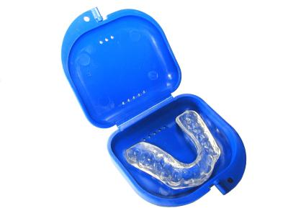
Mouth Guards for Sport.

It's that time of the year again when the days are getting shorter and a little colder, and pre-season winter sports training is moving into top gear.
In the midst of checking whether the kids need new boots, headgear and shin pads, parents and caregivers should also think about booking them in for a check-up with their dentist, and making sure their mouthguard is still fit for use.
Given how quickly children's teeth and jaws change and grow year-to-year, a mouthguard that fitted perfectly last year may not fit so well this year, which can cause a problem since an ill-fitting mouth guard, can do more harm than good.
A custom-fitted mouth guard works by absorbing and spreading the impact of the damaging blow, and is fabricated based on an impression of your teeth and jaw taken by your dentist. Mouthguards can protect you from some serious sporting injuries, such as broken jaws, fractured, cracked or knocked-out teeth, cut lips and tongues.
A mouth guard that is custom-fitted by your dentist is far superior to an over-the-counter mouthguard because it’s specially designed to fit the exact contours of your mouth making it comfortable to wear, is resilient, balances your bite and allows speech and normal breathing. If properly used, stored, and checked by your dentist every year, a custom-fitted mouthguard should last several seasons.
In contrast, self-fitted, over-the-counter mouthguards, which include what are commonly known as boil-and-bite mouthguards, should not be used. They do not protect the teeth, are loosely fitted, impede breathing and speaking, and can even wedge in the back of the throat at impact which could be life threatening.
Only dental professionals can design and manufacture a custom-fitted mouthguard that provides adequate protection.
